Morgan, Henry

Mini project 3
Team 4

Contents Table
Contents
Contents Table 1
Testing Table 6
Protocols Concepts and their explanation 7
Difference between Area networks 8
Explanation of Client server model 9

Evidence for network build
This is the evidence for the FILUS networking build created
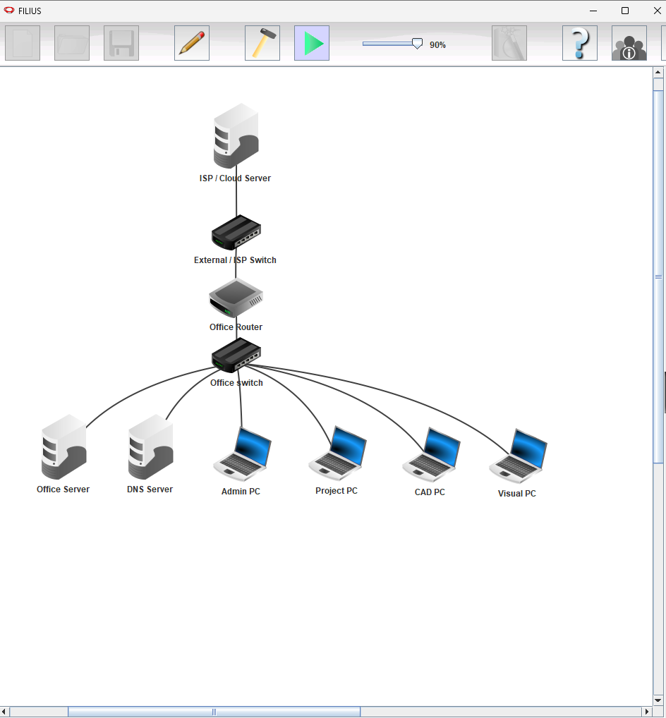
This is the network topology of the office and cloud server/system it connects to, as you can see, it's a simple network structure showing two servers (Office server and DNS server) connecting to the offices switch, that then connects to the rest of the computers on the network that would be the clients of the network accessing the office server, the office switch is connected to a router that is connected to an external/ISP provider switch that allows the internal office to communicate with the cloud and internet and actually make external communication with the rest of the world
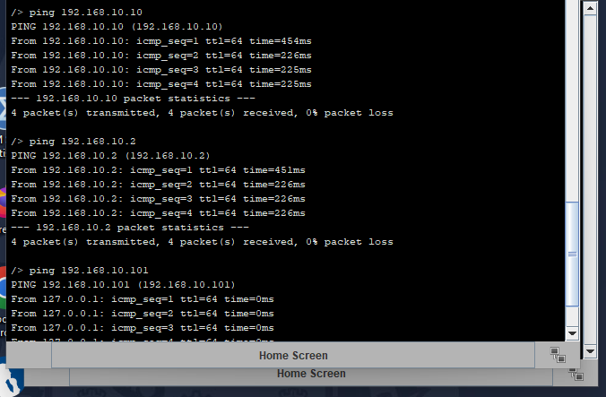Successful pings from the admin PC to another PC, the office server and the DNS server

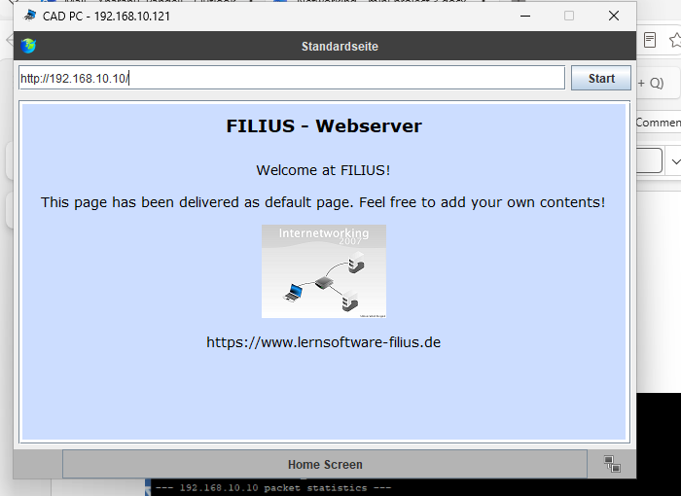Screenshot to prove that the HTTP client server work internally
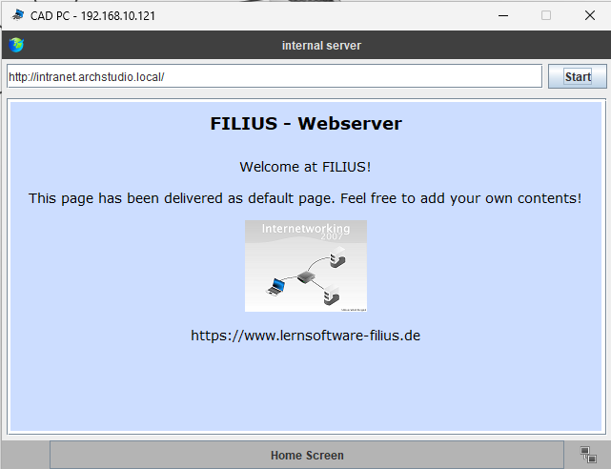
Screenshot showing HTTP client server can be accessed though name rather than IP address
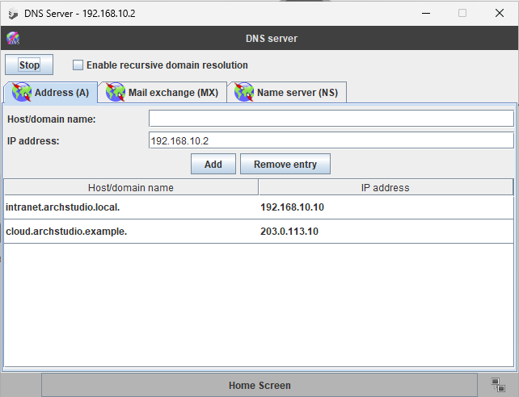
This screenshot shows the DNS server and the addresses it contains that get redirected to the local webserver and the cloud/isp webserver.
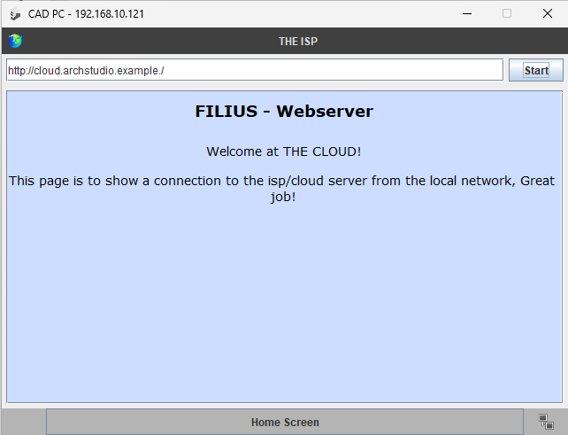
This screenshot Shows that a connection to an External web address by name is working as intended.
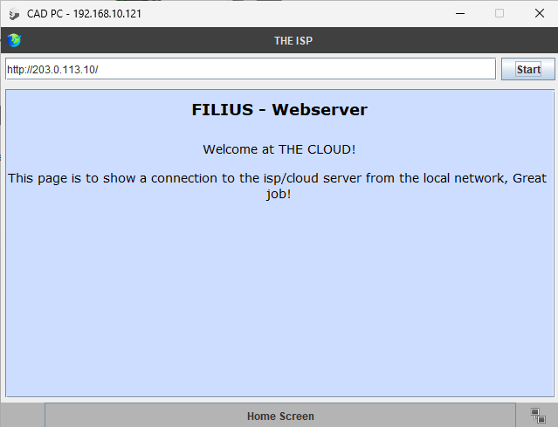
And this screenshot shows the external webserver being accessed using its IP address instead.

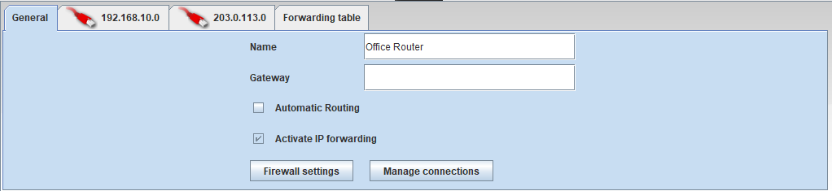This is the screenshot of the router details.

Testing Table
Test | Action | Expected result | Functional?
LAN PC-to-PC | ping 192.168.10.101 | Office LAN devices communicate through the switch. | ✓
PC to Office Server | ping 192.168.10.10 | Client can reach the internal server. | ✓
PC to DNS Server | ping 192.168.10.2 | Client can reach the DNS service. | ✓
Internal web by IP | http://192.168.10.10 | HTTP client-server works internally. | ✓
Internal web by name | http://intranet.archstudio.local | DNS resolves the internal name to its IP. | ✓
External server ping | ping 203.0.113.10 | Router connects the office LAN to the external network. | ✓
External web by IP | http://203.0.113.10 | Client can access an external service. | ✓
External web by name | http://cloud.archstudio.example | DNS resolves the external service name. | ✓

Protocols Concepts and their explanation
Concept | Explanation
TCP/IP | TCP/IP stands for transmission control protocol/internal protocol, to explain it simply, it is the foundation set of rules/stages of communication computers need to take whenever data is being sent/received online. There are 4 layers in TCP/IP these include  L4 – application: programs and services that use the network, e.g., HTTP, DNS, FTP, SMTP  L3 – transport uses TCP and UDP to move data between applications (TCP is slower but more reliable, UDP is faster but less reliable)  L2 – Internet: IP routes packets between networks using IP addresses  L1 - link/physical: the final and local delivery over the physical medium, e.g., ethernet cable, WI-FI, 802.11
DNS | DNS (Domain Name System) is a system that translates human-friendly website names into IP addresses that allows computers to talk to each other.  Initially, when you type a web address into the browser, the device is not of aware of where the site lives. It requires an IP address (for example:192.0.10.8) to connect.  Step-by-step:  The request: Your browser requests for a recursive resolver (usually run by your internet provider) for the IP address.  Root Servers: If the resolver does not identify the address, it requests for a root name server, which guides towards the right extension  TLD Servers: Top-Level Domain servers (for example: .com or .co.uk) direct the search to the specified domain’s official home.  Authoritative Servers: authoritative name server gives the final address back to the device so the page can finally load.
HTTP / HTTPS | HTTP (or Hyper Text Transfer Protocol) is a protocol designed for viewing and sharing information on the world wide web. Its header contains a hyperlink that is re-routed though a DNS server to a specified IP address, the request is then sent to the specified destination (usually a web server) which contains information about what the Senders PC would like from the server. The response contains the status of the request and usually a HTML (and CSS, JavaScript etc) document which is then interpreted by the browser in the form of a web page. The ‘S’ at the end of HTTPS stands for secure, this just guarantees the client that the connection to the server is secure, and information cannot (without great effort) be interloped by a third party.
IP Addressing | A unique number assigned to a device on a network. It is used to identify the device and allows data to be sent to and from it over the internet or another network.
ICMP / ping | ICMP Ping is a network tool used to check whether a device is reachable over a network. It sends an ICMP Echo Request to the target device, which should respond with an ICMP Echo Reply. This can also be used to measure the response time (latency) between the two devices.

Difference between Area networks
A Local Area Network (LAN) connects devices within a single small site like a home or small office complex, while an external network (WAN or just the Internet) connects multiple networks across large distances and/or cities and contains multiple LANs since each area network is like a hierarchy. Going down in such a hierarchy as if you were zooming in would go like such: WANàMANàLANàPAN (Wide, Metropolitan, Local and Personal area networks respectfully)

Explanation of Client server model
The client-server model in networking is where user devices (colloquially known as clients) send requests for resources or services from powerful central computers (servers that contain information) that then process those requests and send back the results.

